37 .Aim :To Design NFA using simulator to accept the string that start and end with different symbols over the input {a,b}.

INPUT:

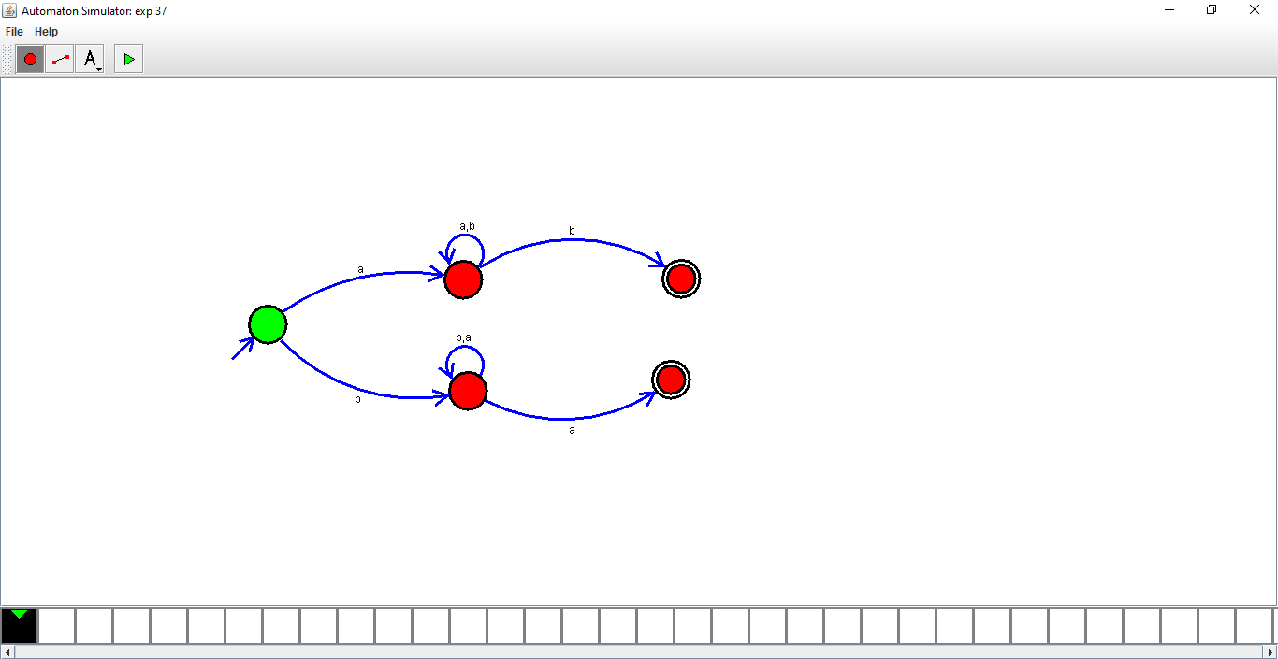

OUTPUT:

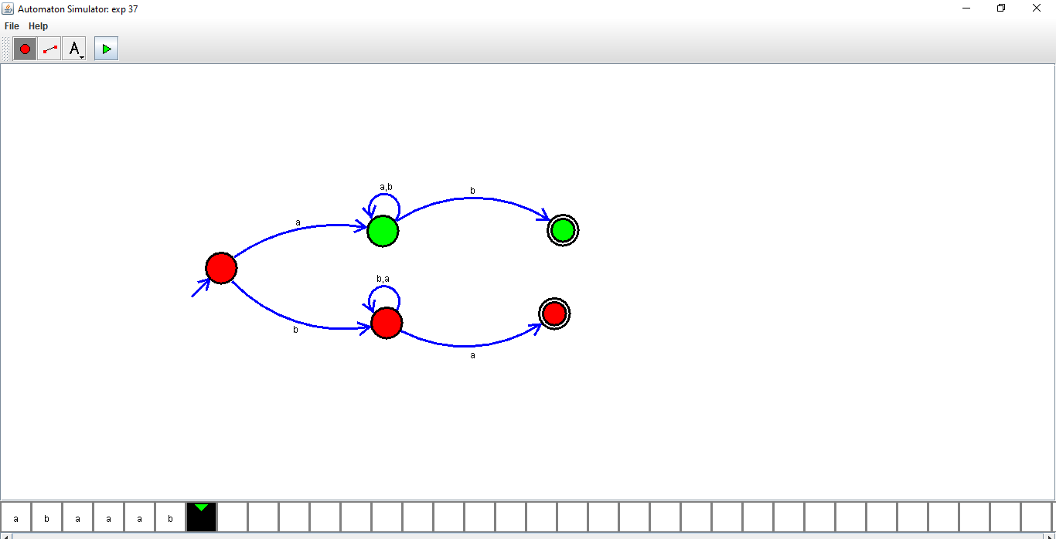

1. RESULTS:Designed NFA using simulator to accept the string that start and end with different symbols over the input {a,b}.